Test Case:

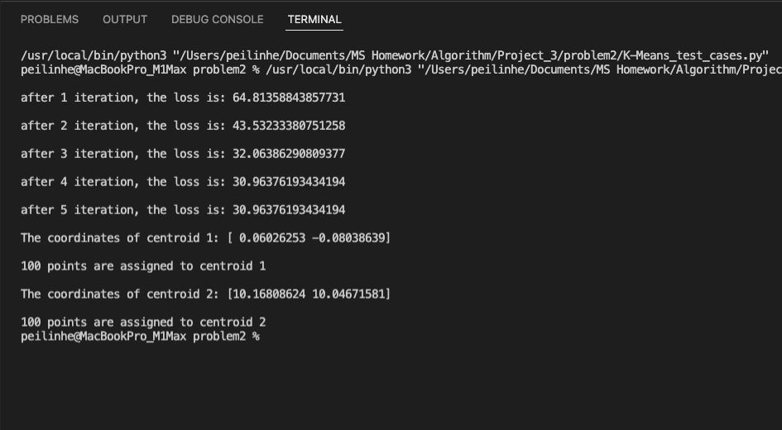

Power Consumptions:

K = 2:

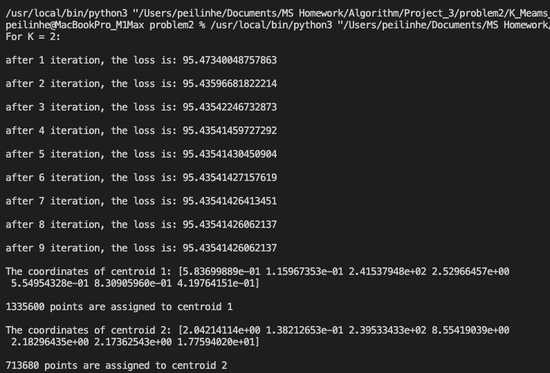

K = 3:

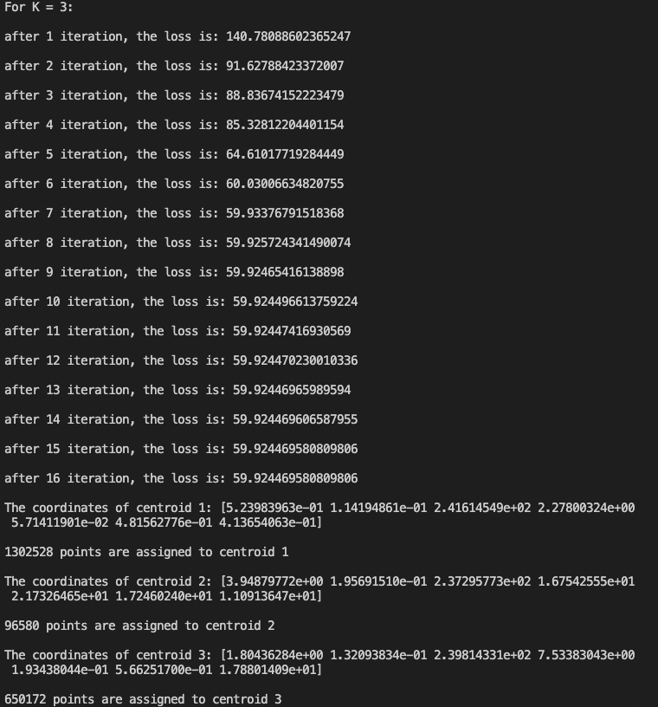

K = 4:

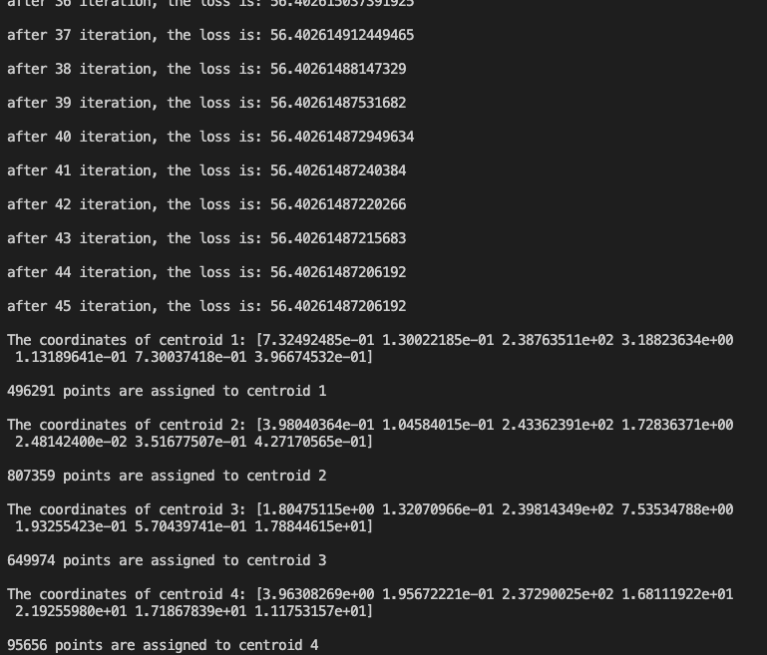

K = 5:

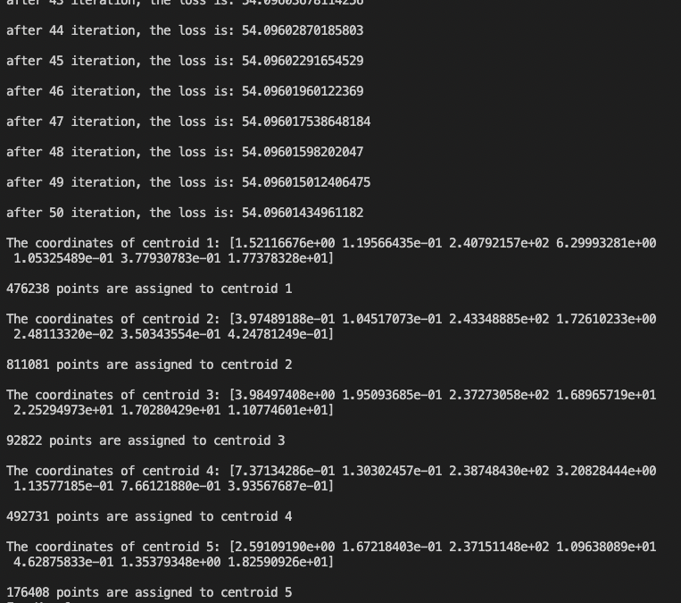

K = 6:

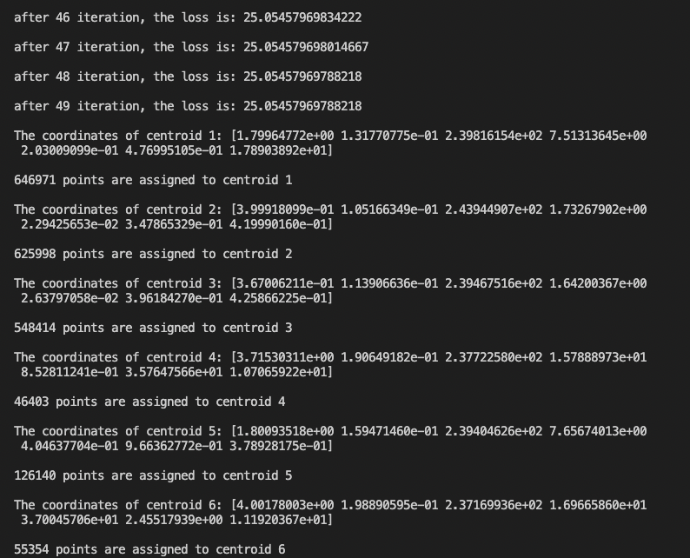

K = 7:

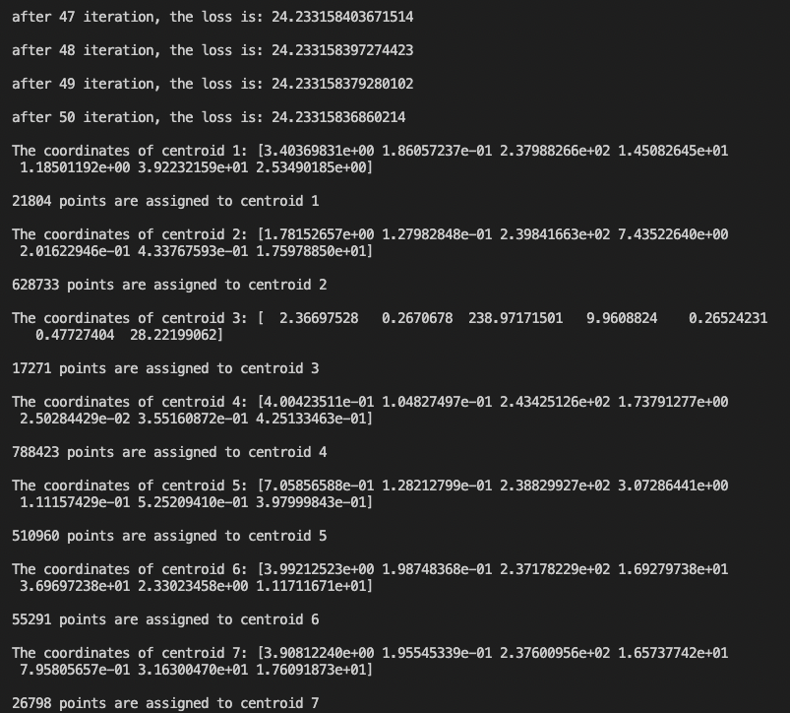

K = 8:

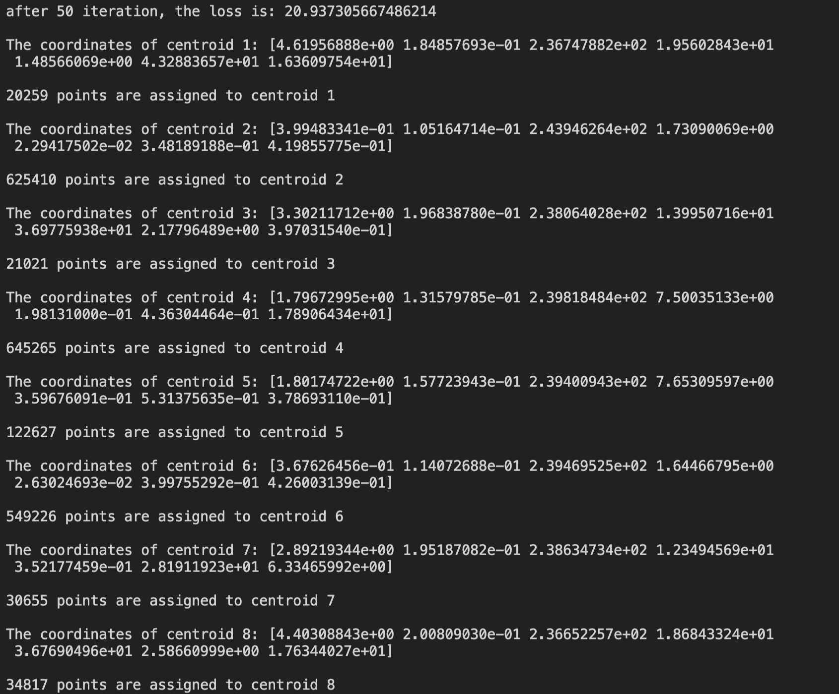

K = 9:

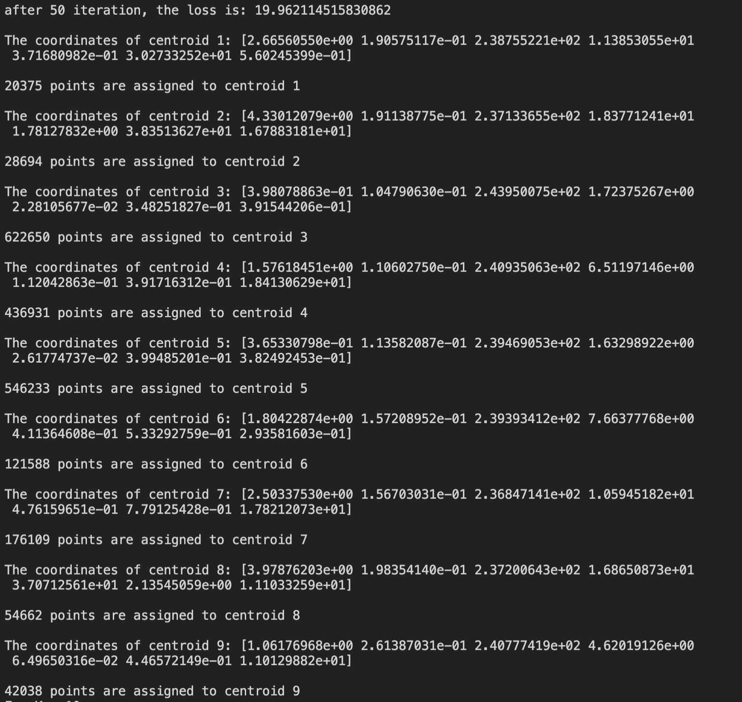

K = 10:

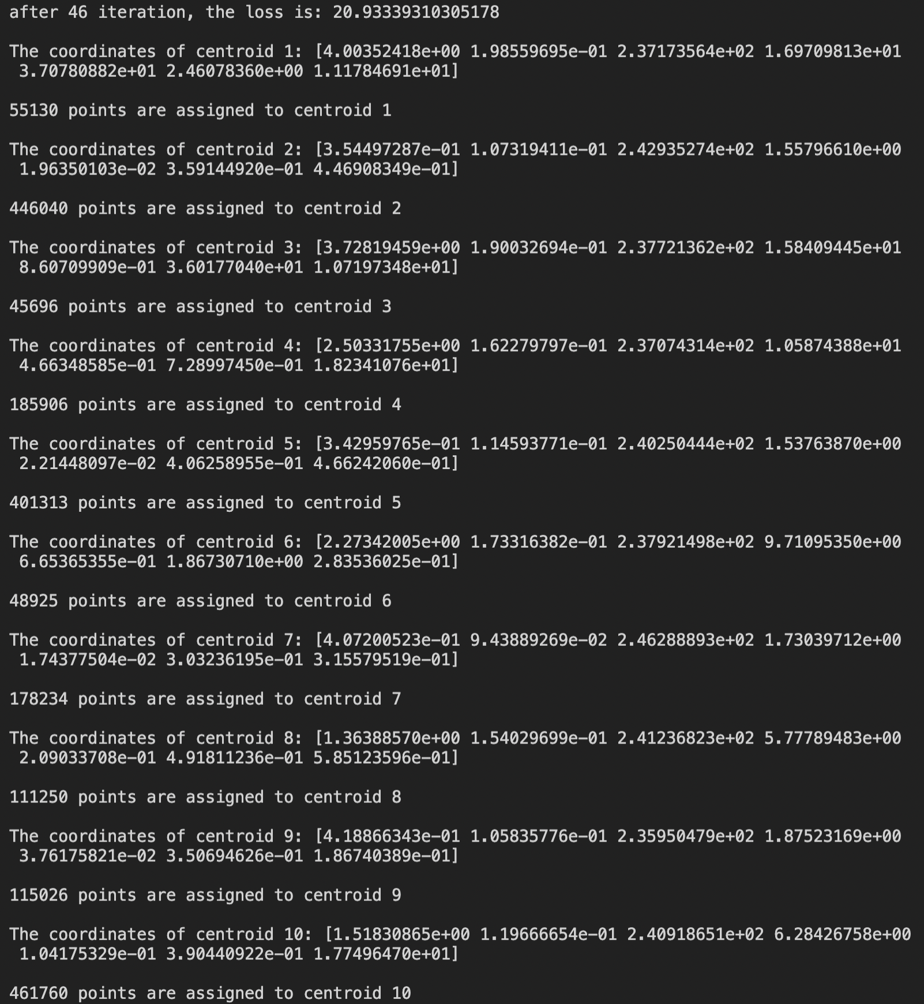

K = 11:

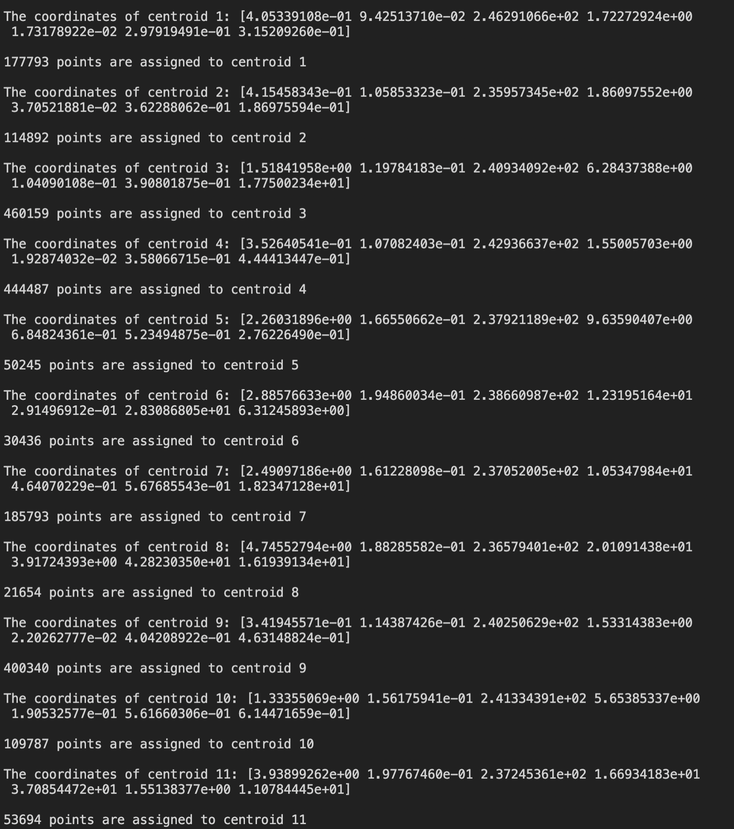

K = 12:

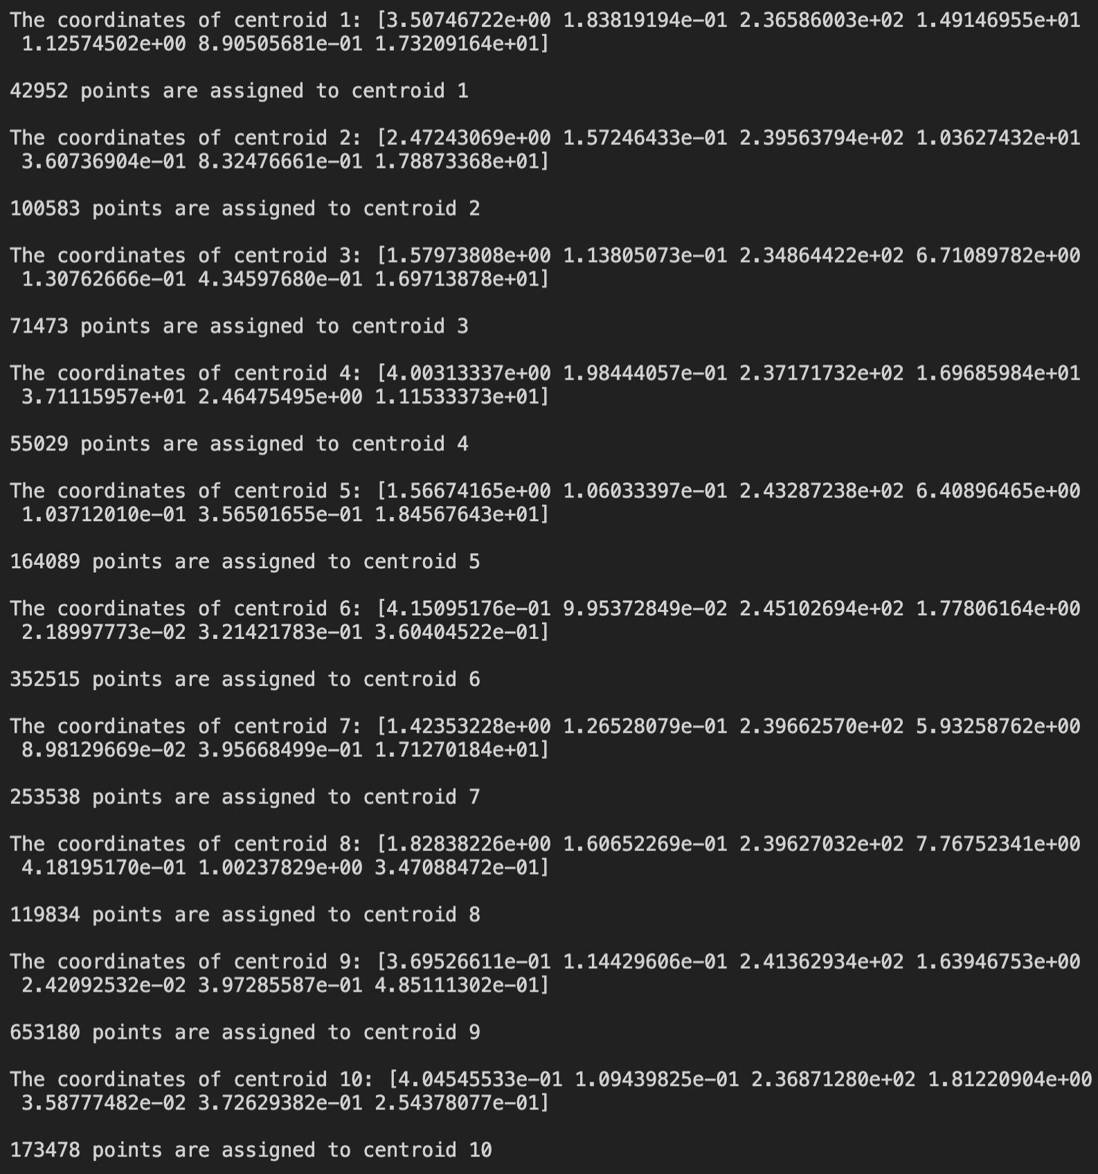

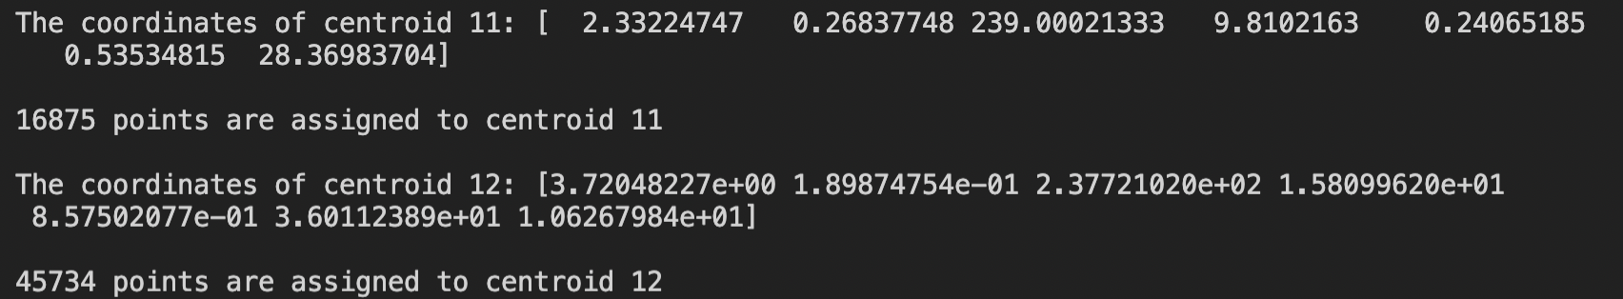

K = 13:

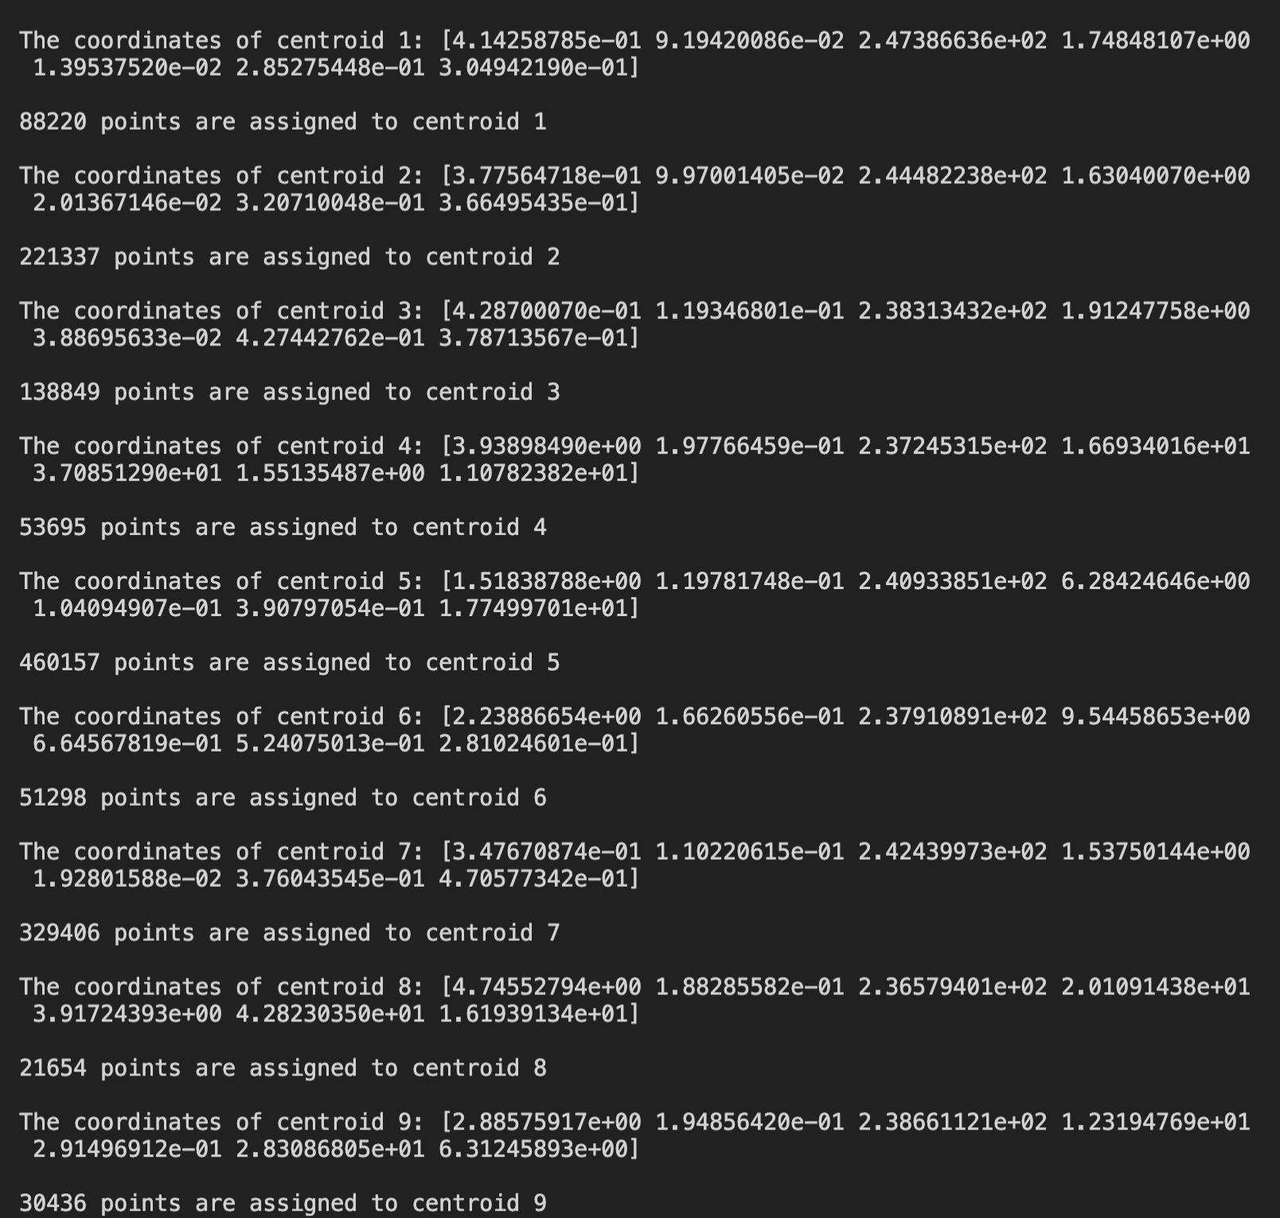

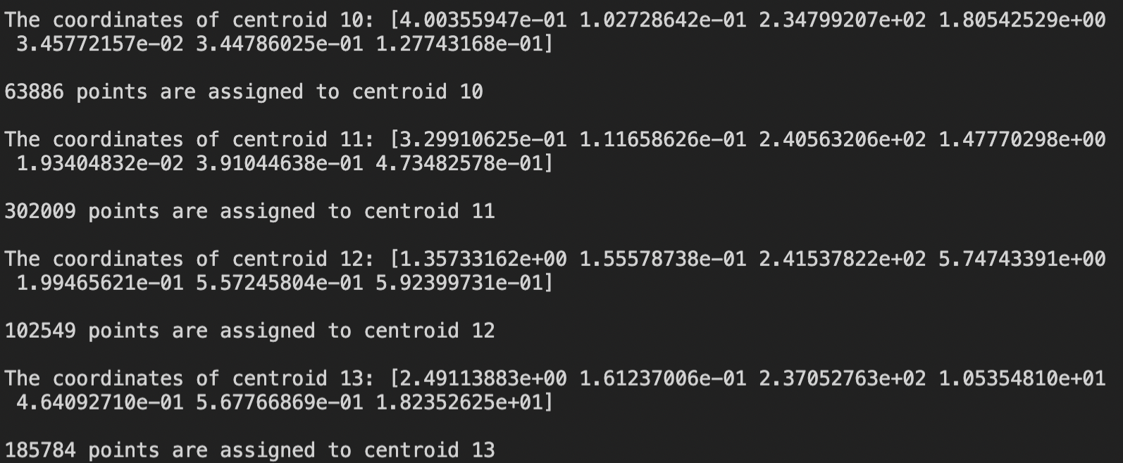

K = 14:

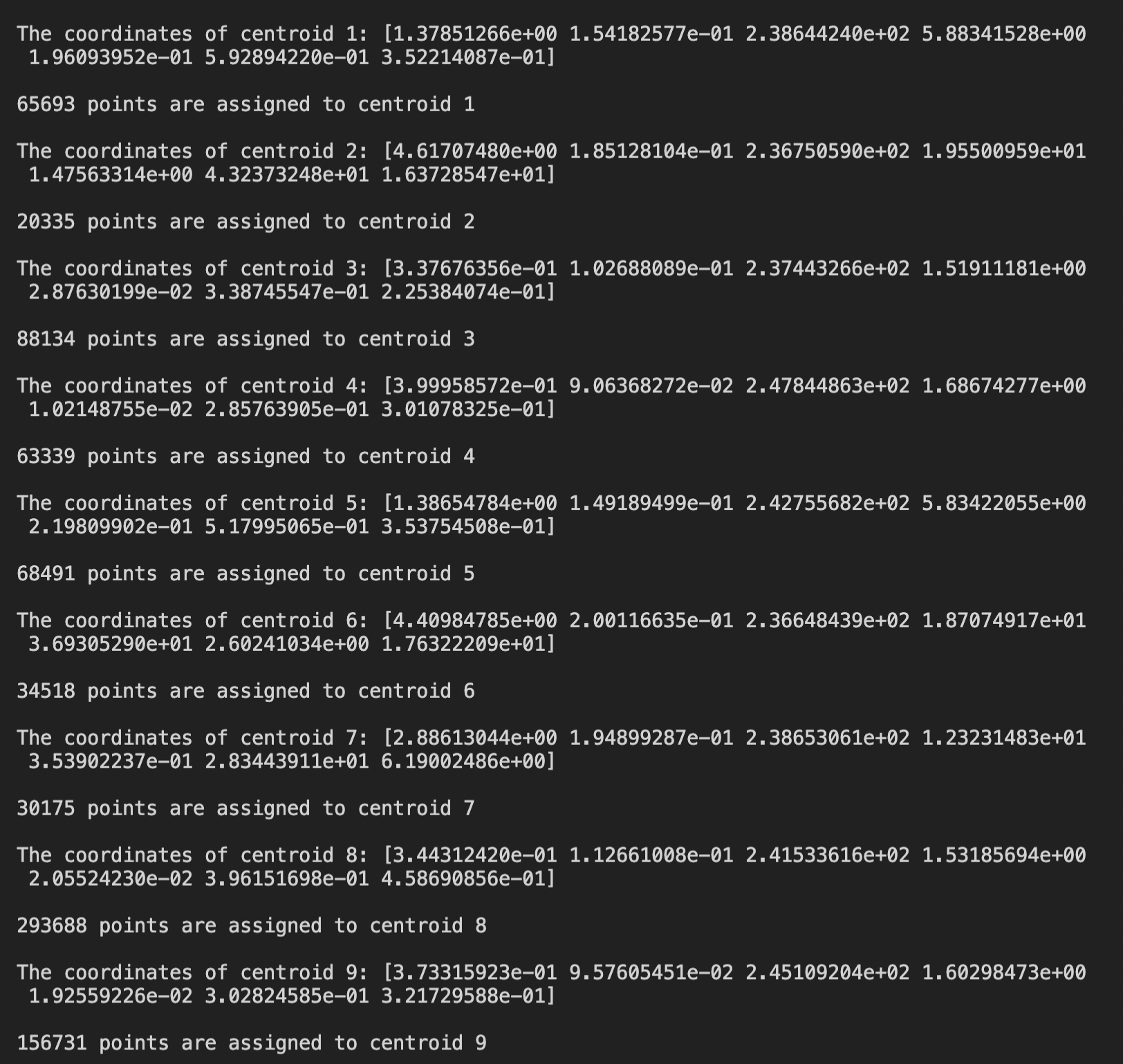

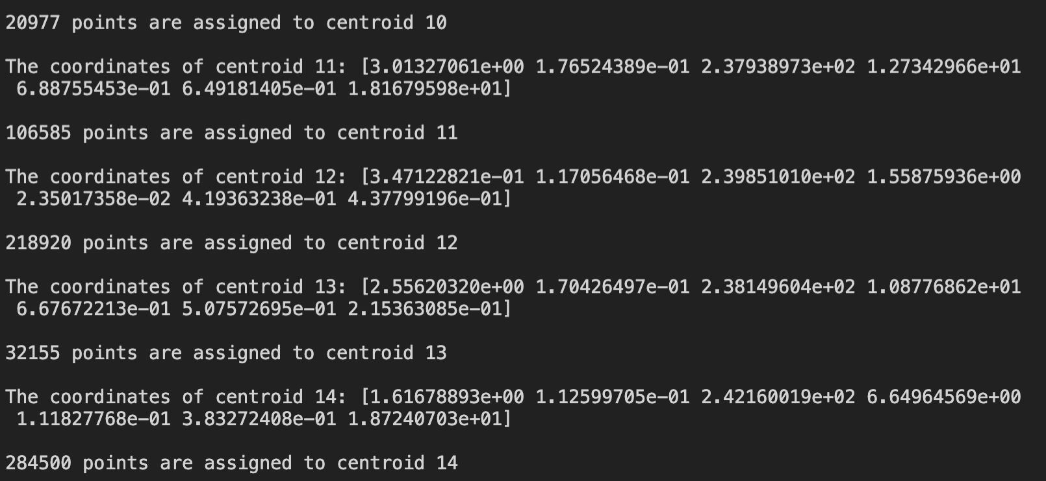

K = 15:

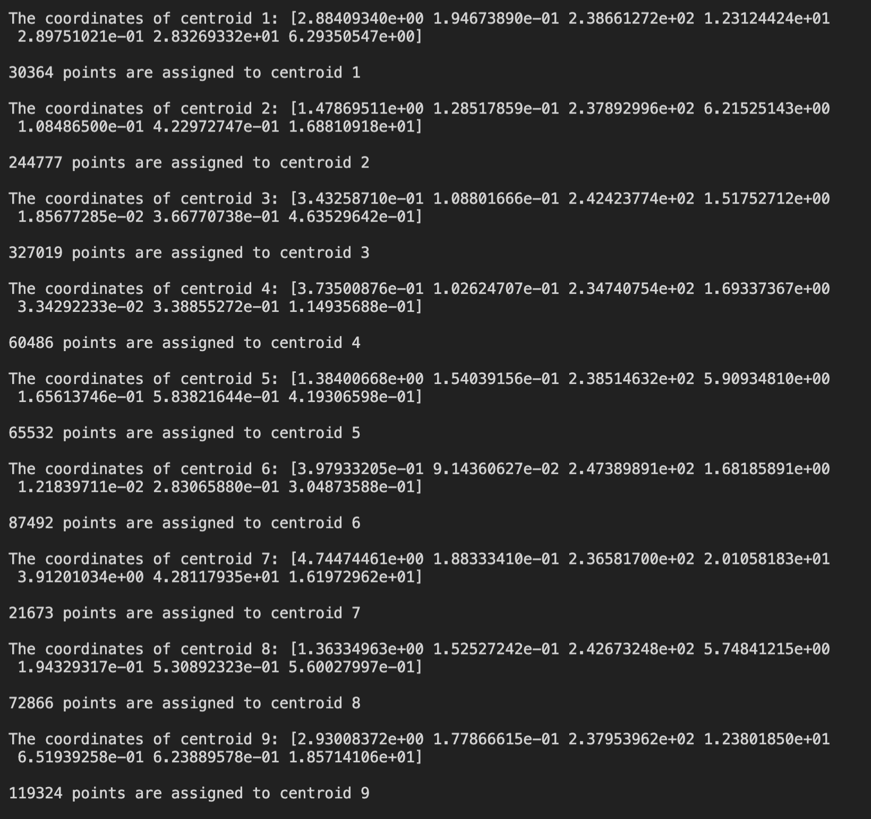

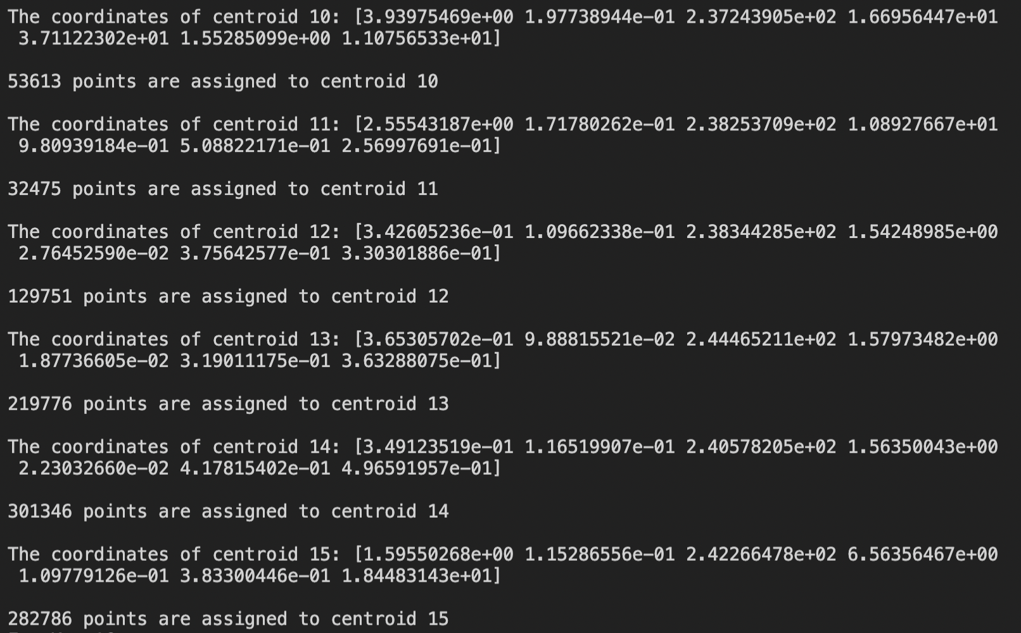

K = 16:

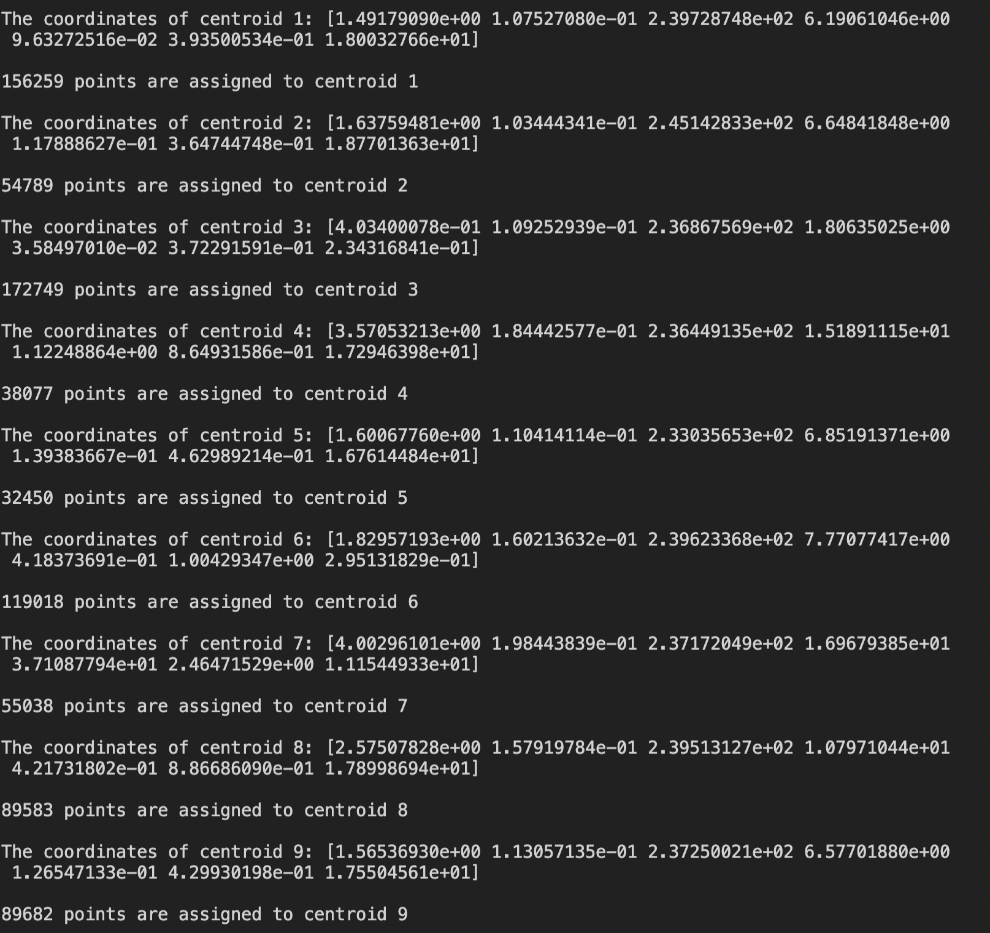

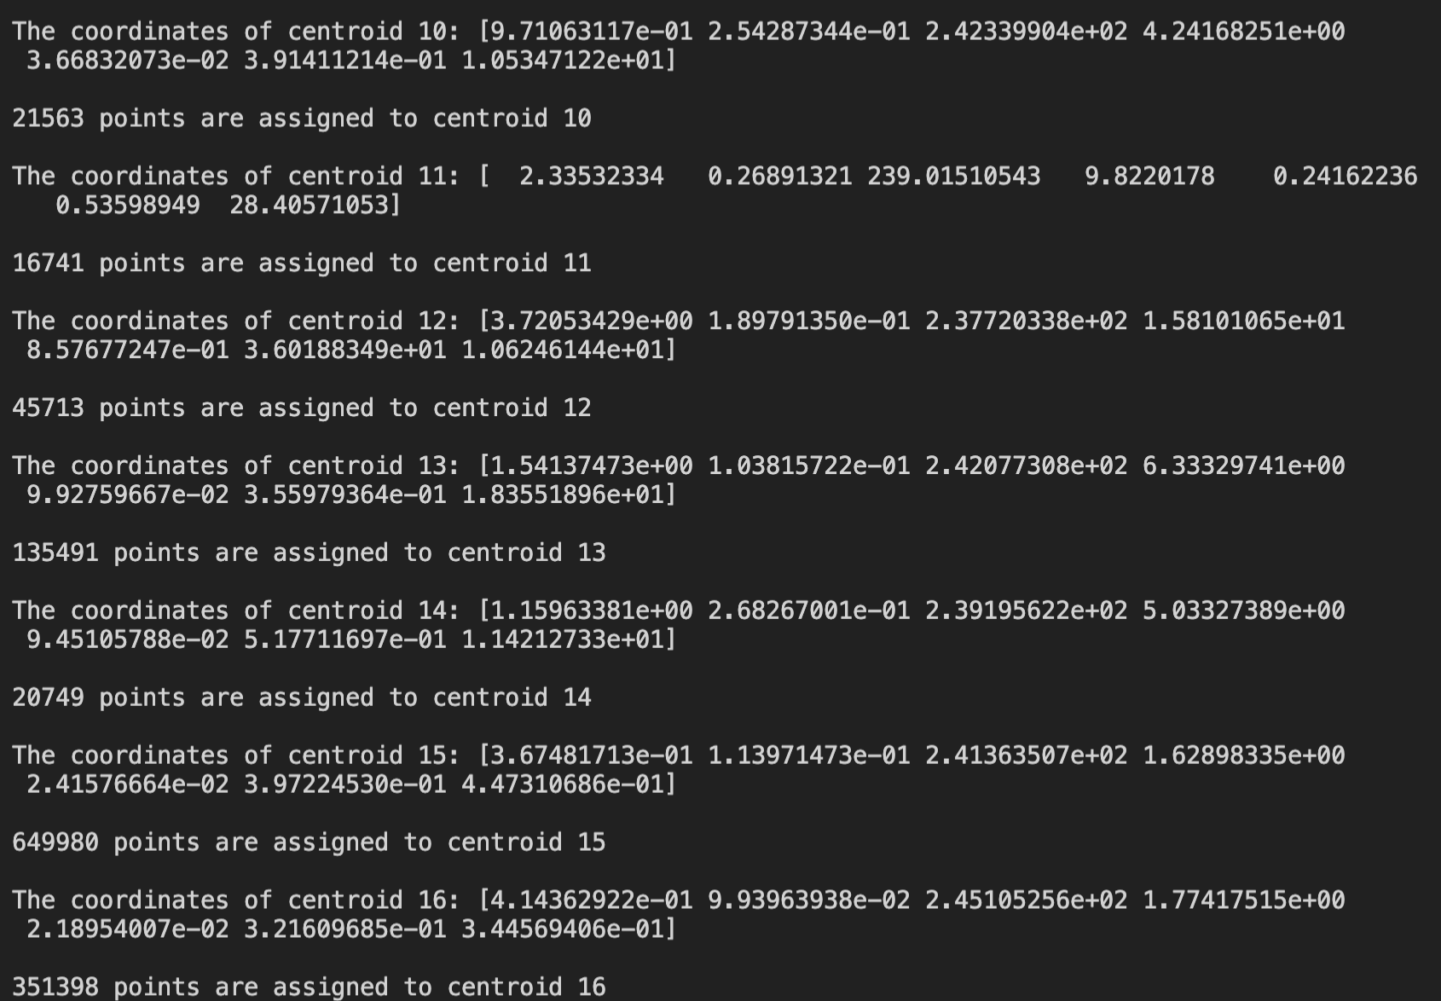

K = 17:

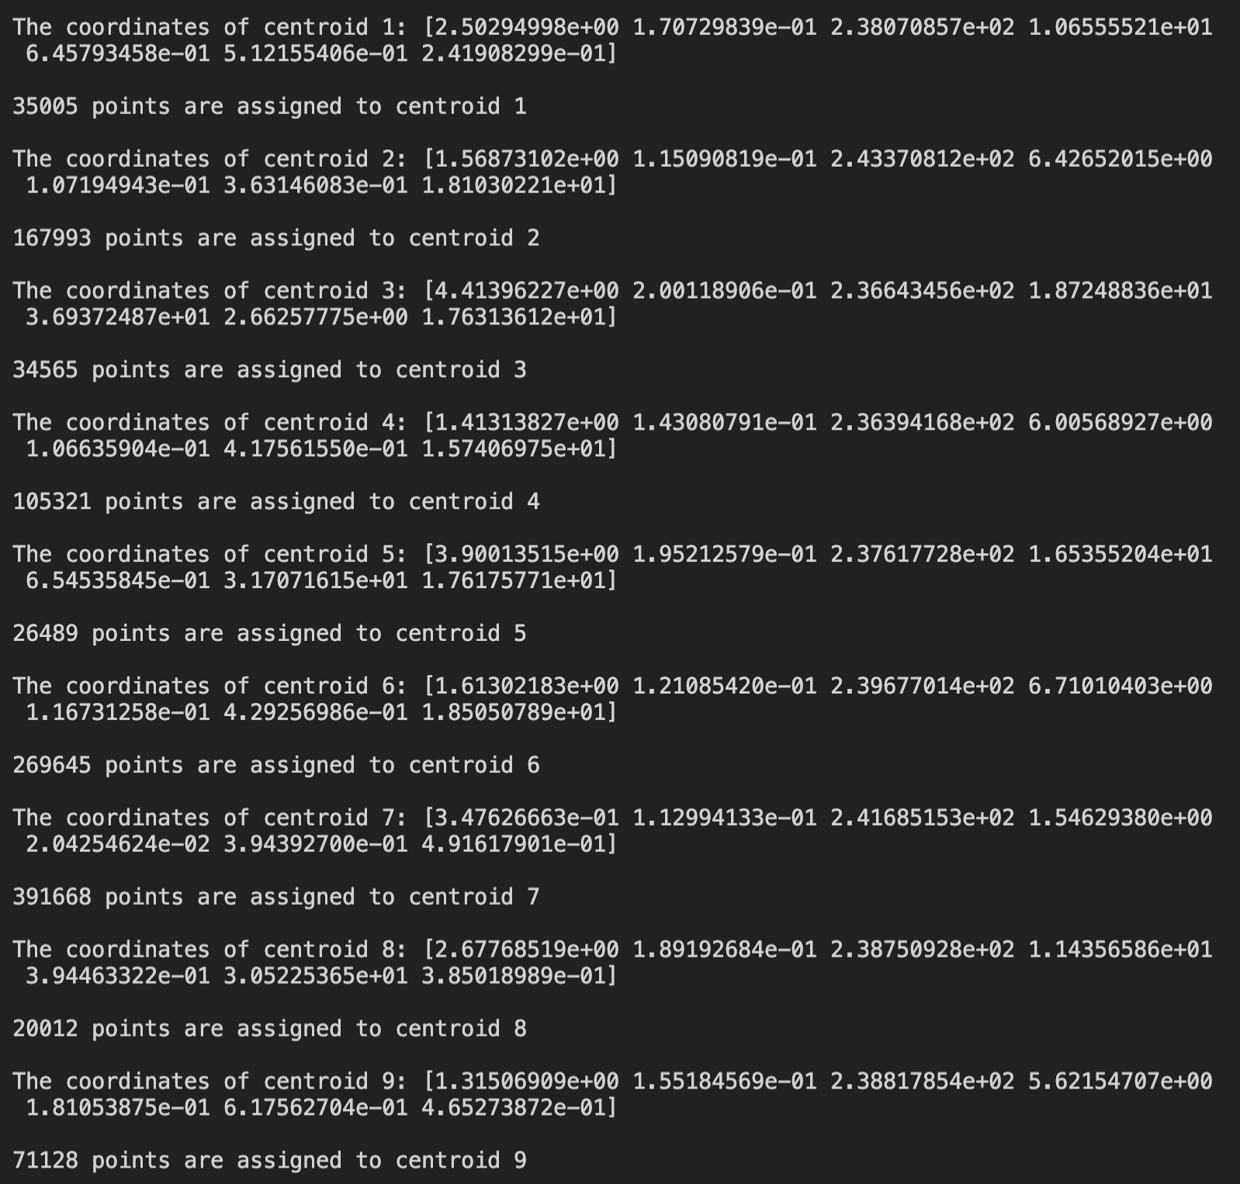

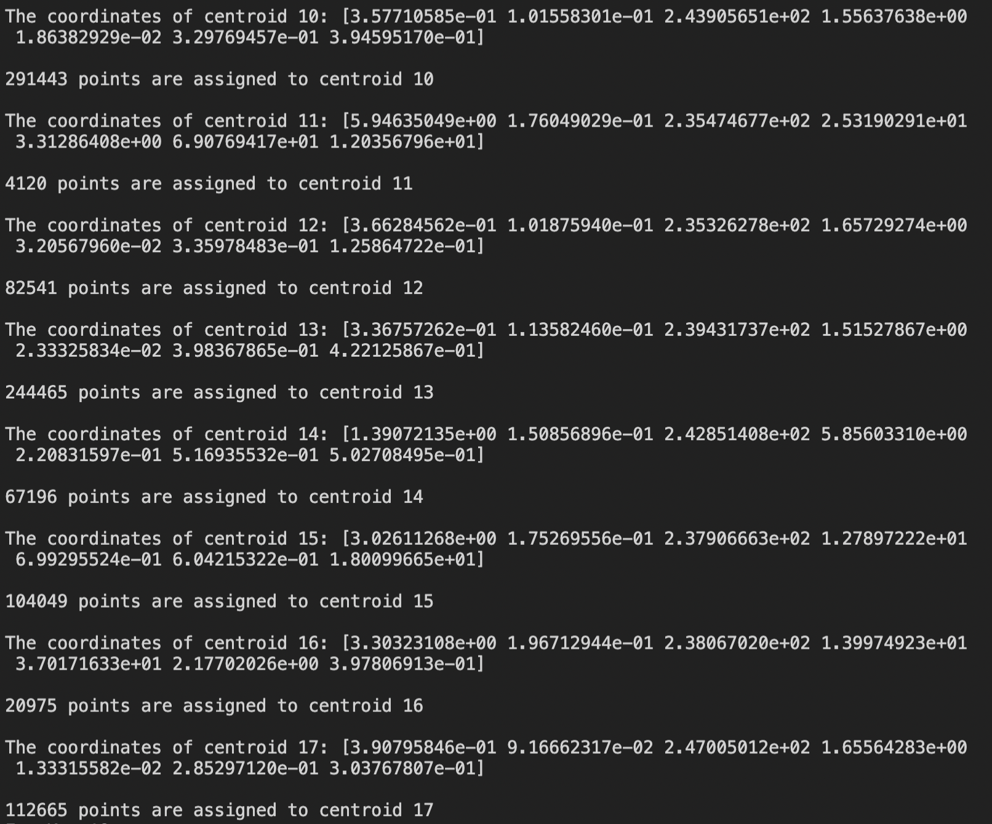

K = 18:

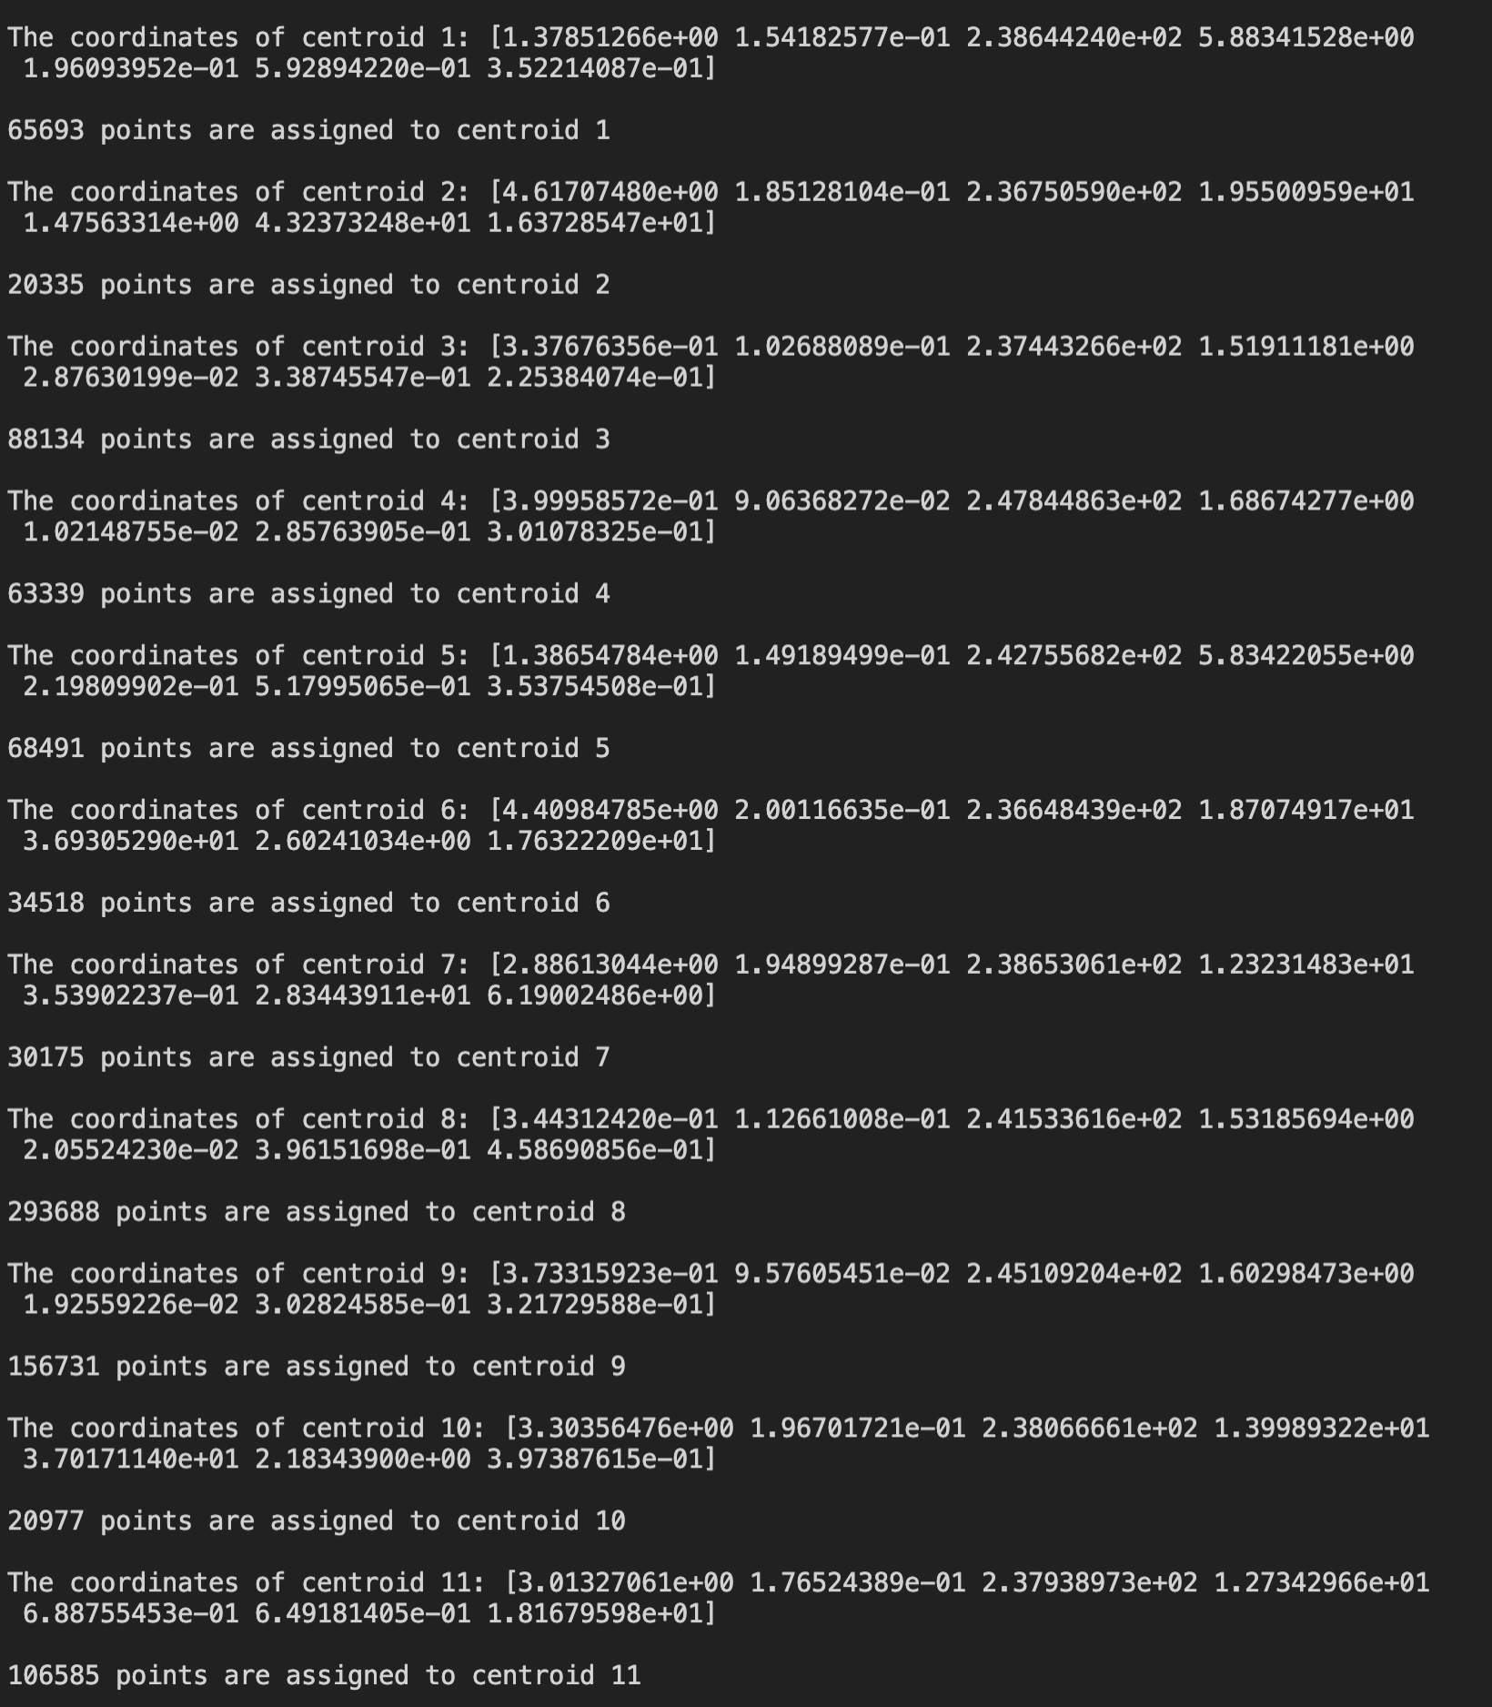

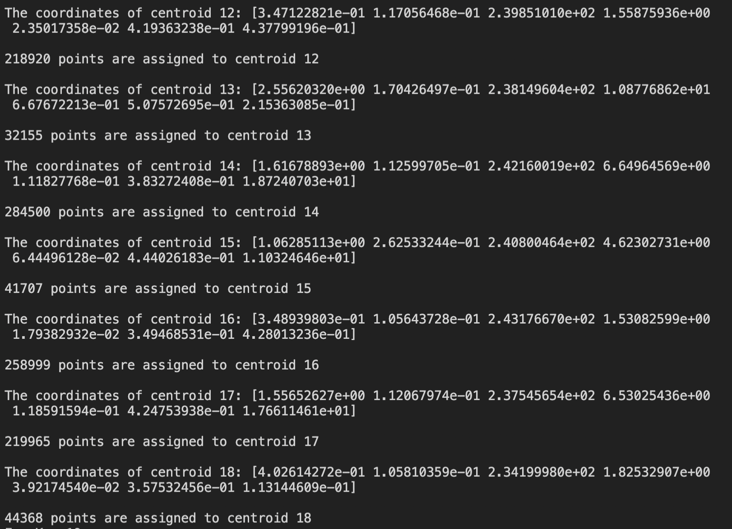

K = 19:

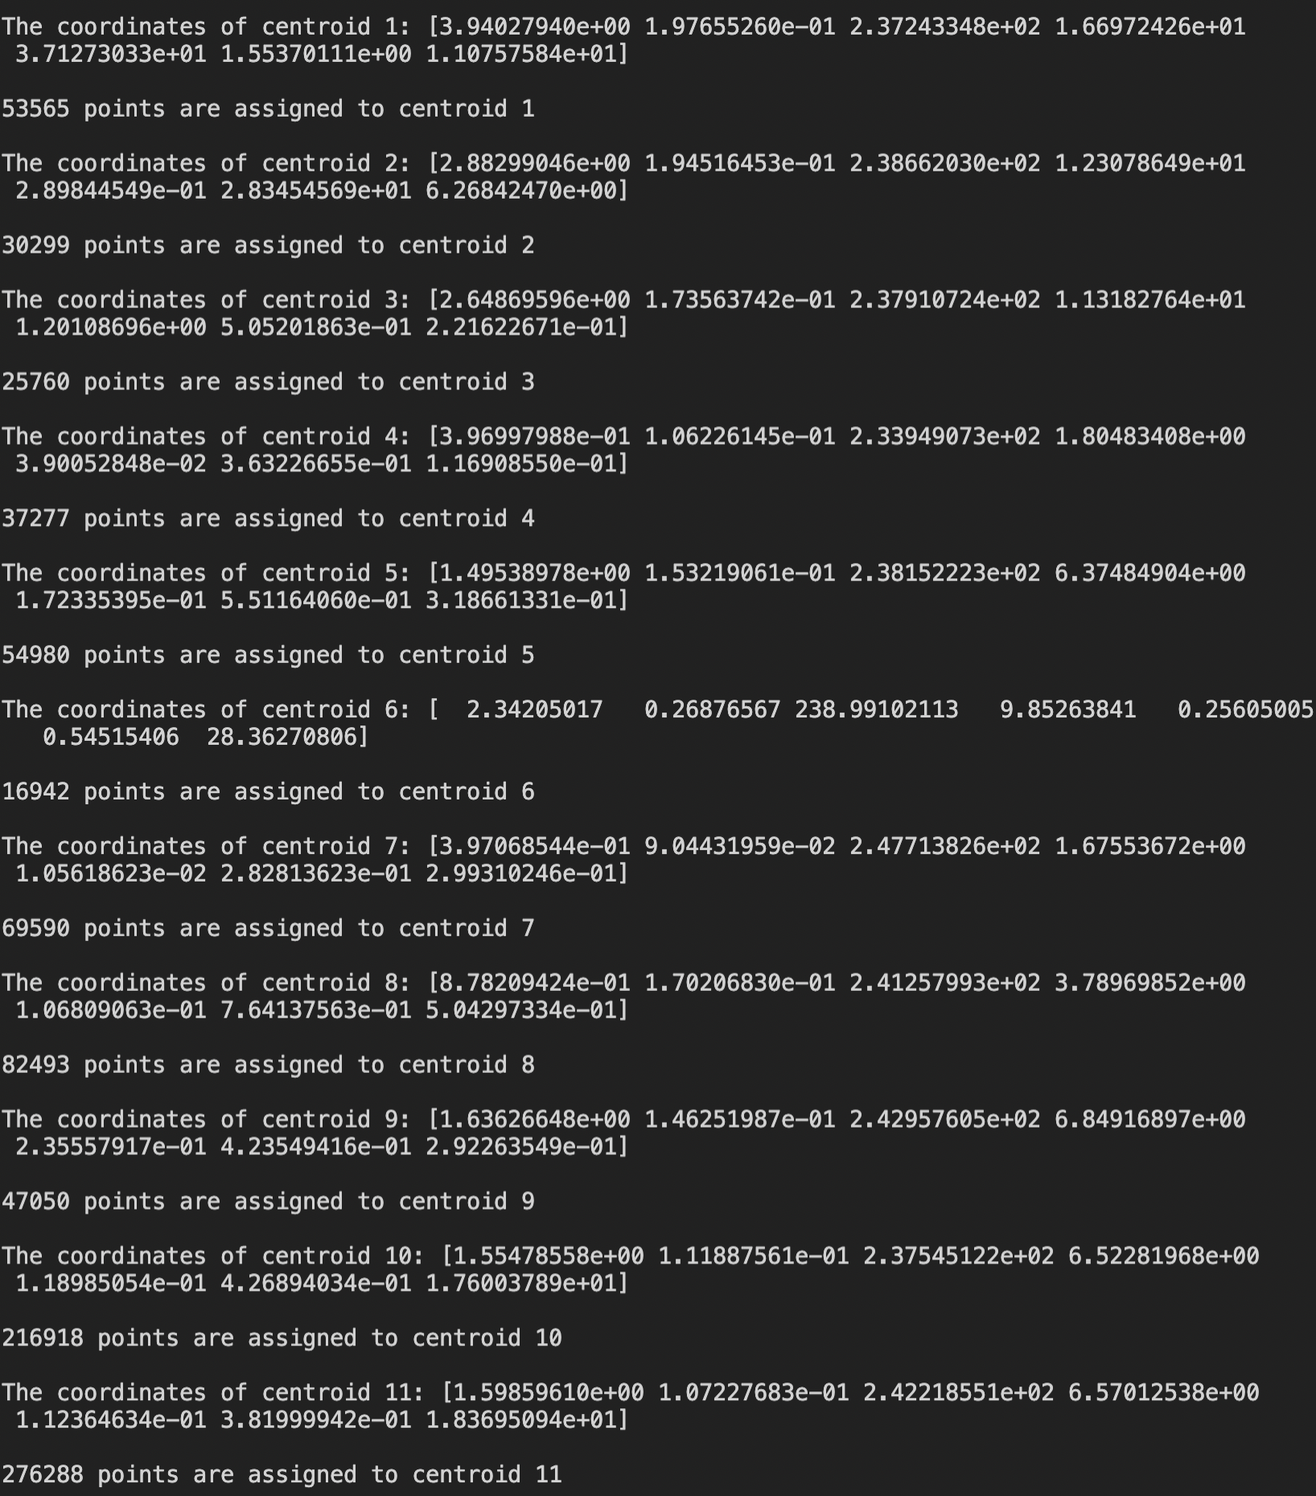

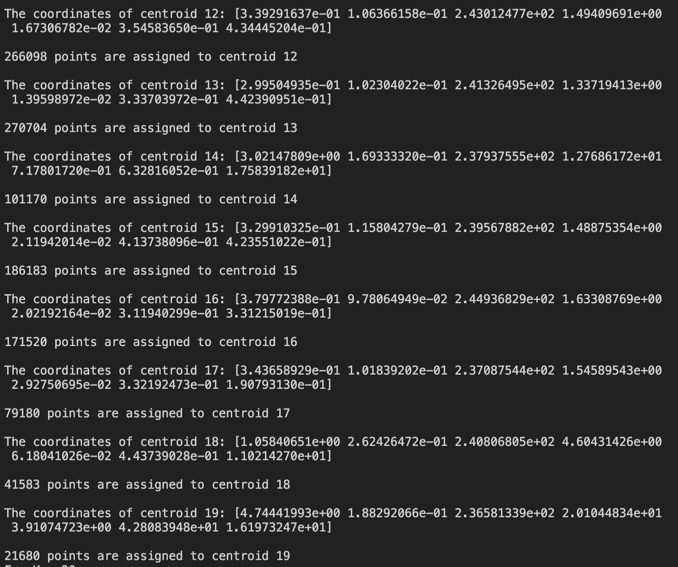

K = 20:

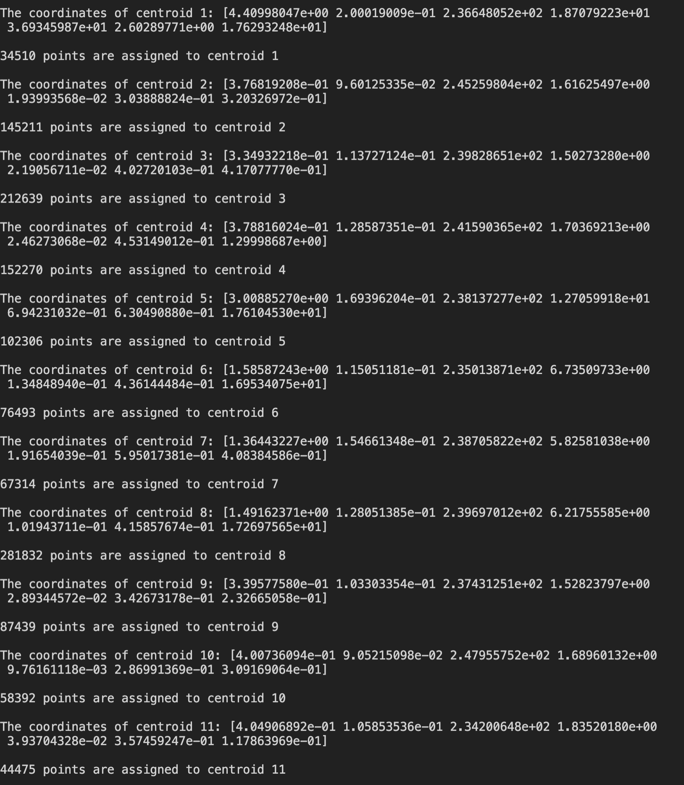

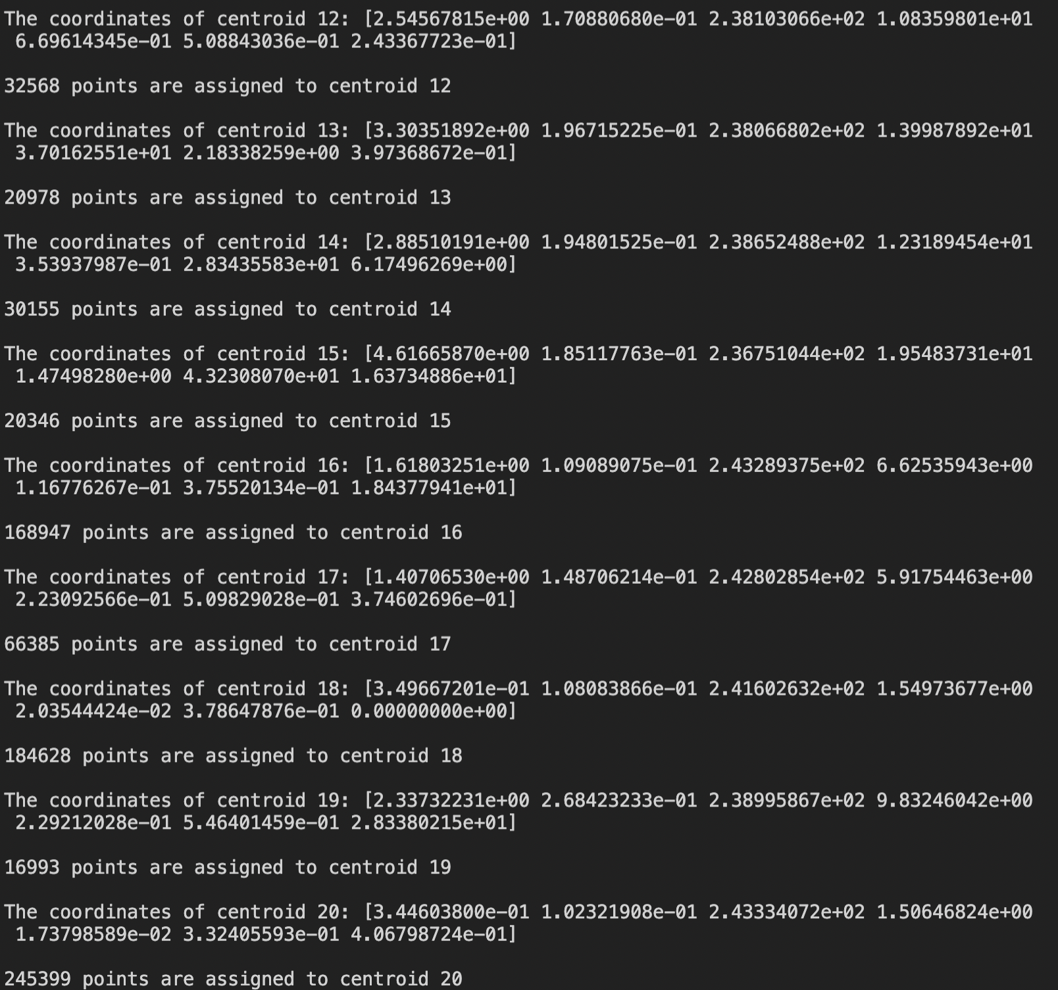

Slot:

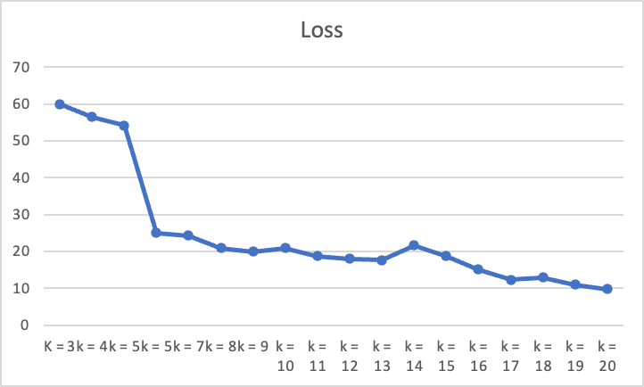

Using the elbow method, the loss rate dropped from K=3 to 5 slightly while decreased significantly after or equals to K =5 then melty again. So, the elbow point equals K=6, and this value of K fits the data best.

Additions:

**Stopping criteria:**

I used two stopping criteria: 1. The change status of clusters. 2. Max iteration times.

If clusters did not change after one iteration (the loss does not change), the clusters well be assigned so we can stop calculation. But sometimes it takes too many iterations to make clusters unchanged. Therefore, we should set a maximum of iteration in order to avoid wasting time and memory on tiny loss convergence rate. Generally, when K increases, the loss needs more and more iterations to converge completely. Limited by the computing power, I set my number of iterations for 50 maximums, which makes me unable to calculate the final convergence value of losses for that K. Thus, the results may not perform very well about clustering the data.

**Centroid initialization method**:

In my algorithm, I randomly select K points for all data as the initial clusters. the initial clusters could be different for the same input and parameters. For each time running the code, different initial clusters can require different time to produce the different results. Because if the algorithm selects lucky initial clusters which are close to the results, the less time will be required. Moreover, for the same K, the final clusters’ coordinates may not be unique depends on the initial clusters, which means the final loss can be different after each time of running program. For this problem, we can run the program for many times (eg.50) and pick clustering that gave the lowest loss.